**Associative Learning in Neural Networks**

**Definition:**  
Associative learning, in the context of neural networks, refers to the ability of a network to form connections between input and output patterns. This process mimics how biological neurons associate stimuli and responses. Neural networks learn these associations through training, where the weights between neurons are adjusted to strengthen the mapping between specific inputs and desired outputs.

**Biological Inspiration:**  
Inspired by Hebbian Learning, often summarized as:  
“Neurons that fire together, wire together.”  
When two neurons are activated simultaneously, the connection (synapse) between them becomes stronger, forming an association.

**Types of Associative Learning in Neural Networks:**

1. **Supervised Learning (Input-Output Association):**  
   The network learns to map inputs (features) to outputs (labels).  
   Commonly used in feedforward neural networks.  
   Example: A neural network learns to associate images of digits with their respective labels (0–9) using training data.
2. **Autoassociative Networks:**  
   Learns to recall entire patterns from partial or noisy inputs.  
   Example: Autoencoders – compress and reconstruct data, forming internal representations (associations).  
   Useful for denoising, compression, and anomaly detection.
3. **Heteroassociative Networks:**  
   Associates one set of patterns with another set.  
   Example: Hopfield Networks, Bidirectional Associative Memory (BAM).  
   Can retrieve an output pattern from a different but associated input pattern.

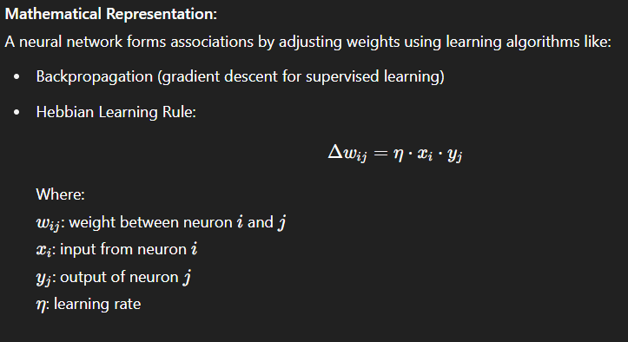

**Applications:**

* Pattern Recognition: Associating images with labels (image classification)
* Natural Language Processing (NLP): Word embeddings learn associations between words
* Recommendation Systems: Associating users with items they prefer
* Memory Simulation: Using Hopfield networks to simulate associative recall

**Example:**  
In a feedforward neural network trained on animal images:  
Input: Pixel values of an image of a cat  
Output: Label "Cat"  
The network learns to associate this pixel pattern with the label "Cat" by adjusting weights during training.

**Hopfield Network – In Depth**

**1. Introduction:**  
A **Hopfield Network** is a type of **recurrent neural network** used for **associative memory**. Introduced by John Hopfield in 1982, it is capable of storing patterns and retrieving them when given incomplete or noisy input. It is mostly used in pattern recognition, optimization, and memory-related applications.

**2. Structure:**

* Composed of **binary neurons** with values +1 (active) or -1 (inactive).
* **Fully connected**: Each neuron is connected to every other neuron.
* **Symmetric weights**: The connection from neuron A to B is equal to B to A.
* No neuron is connected to itself (i.e., no self-loops).

**3. Pattern Storage (Learning Rule):**  
The network stores patterns using **Hebbian learning**, where the weights between neurons are calculated based on the training patterns.

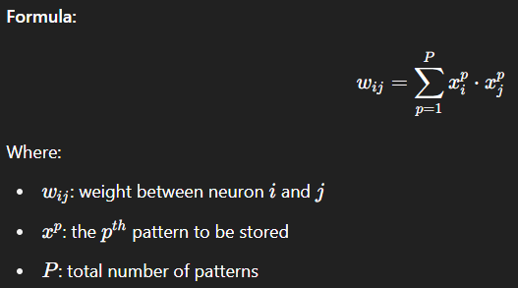

This rule strengthens connections between neurons that are active together.

**4. Pattern Recall (Working Mechanism):**  
When a noisy or partial input is given, the network updates each neuron one by one using input from other neurons. This process continues until the pattern becomes stable — this final pattern is the recalled memory.

**Update rule:**

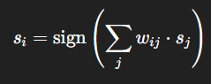

This means a neuron checks the signals from all other neurons and changes its state if needed.

**5. Energy Function (Stability Concept):**  
The Hopfield Network uses an **energy function** that always decreases with each update, ensuring the network reaches a stable state (like a ball rolling downhill).

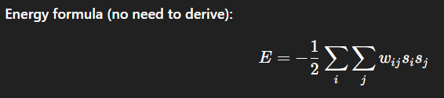

Lower energy means more stability, and the network stops updating when the energy is at its minimum.

**6. Applications:**

* **Pattern recognition** (e.g., recognizing characters even when partly erased)
* **Noise removal**
* **Associative memory** (like remembering a face from partial features)
* **Solving simple optimization problems**

**7. Advantages:**

* Can complete incomplete or distorted inputs.
* Converges to a stable state.
* Simple architecture and learning method.

**8. Limitations:**

* Can store only a limited number of patterns.
* Sometimes retrieves incorrect or mixed-up patterns (called spurious states).
* Works only with binary data (+1/-1).
* Not designed for sequential or time-series data.

**Error Performance in Hopfield Networks**

**1. Introduction:**  
Error performance in a Hopfield Network refers to its ability to correctly recall stored patterns and the likelihood of producing incorrect or unstable outputs. Since Hopfield Networks are used for associative memory, evaluating how often the network **fails to recall the correct pattern** or **converges to the wrong state** is essential for measuring its effectiveness.

**2. Factors Affecting Error Performance:**

* **Pattern Overlap:**  
  If the stored patterns are too similar to each other, the network may confuse them and converge to the wrong one.
* **Storage Capacity:**  
  A Hopfield Network can store approximately **0.15 × N** patterns reliably, where **N** is the number of neurons. Exceeding this limit increases the chance of errors.
* **Spurious States:**  
  These are false stable states that were not part of the original training patterns. The network might mistakenly settle into one of these, causing recall errors.
* **Noise in Input:**  
  If the input is too corrupted or incomplete, the network might not recover the correct pattern.

**3. Types of Errors:**

* **Recall Error:**  
  The network converges to a wrong stored pattern instead of the correct one.
* **Spurious Convergence:**  
  The network stabilizes on a pattern that was never trained (a spurious state).
* **Non-convergence:**  
  The network keeps changing without settling into any stable pattern (very rare due to energy minimization).

**4. Error Rate and Performance:**

* The error rate **increases** as more patterns are stored.
* For reliable performance, the number of stored patterns should be **well below the network’s capacity**.
* If **P** is the number of stored patterns and **N** is the number of neurons, then reliable storage is when:

P<0.15×NP < 0.15 \times NP<0.15×N

Beyond this, the **probability of error rises sharply**.

**5. Example:**  
If a Hopfield Network has 100 neurons, it can reliably store about 15 patterns. If 30 patterns are stored, the error rate will likely be high due to interference and overlap.

**6. Ways to Reduce Errors:**

* Store **fewer patterns** than the maximum capacity.
* Ensure stored patterns are **dissimilar** (orthogonal if possible).
* Use **asynchronous updates** (one neuron at a time), which reduce instability.
* Add **noise filtering** or preprocessing to input patterns.

**Simulated Annealing – In Depth**

**1. Introduction:**  
**Simulated Annealing (SA)** is a **probabilistic optimization algorithm** inspired by the physical process of annealing in metallurgy. In this process, a material is heated and then slowly cooled to remove defects, allowing atoms to settle into a low-energy, stable state. In computer science, SA mimics this by searching for a **global optimum** in a large solution space.

**2. Why Use Simulated Annealing?**  
In many complex problems, especially those with many local optima (like scheduling, routing, or assignment problems), traditional methods can get stuck in **local minima**. SA helps avoid this by allowing occasional “bad” moves, enabling the algorithm to explore a broader solution space.

**3. Basic Working of Simulated Annealing:**

* **Start** with an initial solution.
* **Evaluate** the cost (or energy) of the current solution.
* **Generate a new neighboring solution** by making a small change.
* **Calculate the change in cost (ΔE):**
  + If the new solution is better (ΔE < 0), accept it.
  + If it's worse (ΔE > 0), accept it **with a probability** based on a temperature parameter:

P=e−ΔE/TP = e^{-\Delta E / T}P=e−ΔE/T

* **Gradually reduce the temperature (T)** over time.
* Repeat the process until the system “freezes” (temperature is low and no changes occur).

**4. Key Components:**

* **Solution space**: All possible answers to the problem.
* **Energy or cost function**: Measures how good or bad a solution is.
* **Temperature (T)**: Controls the probability of accepting worse solutions. Higher temperature = more exploration.
* **Cooling schedule**: A rule for reducing temperature, such as:

T=T0×αkT = T_0 \times \alpha^kT=T0​×αk

where T0T_0T0​ is the initial temperature, α\alphaα is the cooling rate (0 < α < 1), and kkk is the iteration number.

**5. Advantages:**

* Can escape local minima to find a global minimum.
* Simple and flexible.
* Works well on large, complex search spaces.

**6. Limitations:**

* Slower than some modern optimization techniques.
* Requires careful tuning of parameters (initial temperature, cooling rate, etc.).
* No guarantee of finding the exact global minimum, though it's often close.

**7. Applications:**

* **Traveling Salesman Problem (TSP)**
* **Job scheduling**
* **VLSI design layout**
* **Neural network training**
* **Image processing**

**8. Example (Conceptual):**  
Imagine finding the shortest route to visit multiple cities (TSP). SA starts with a random path, then gradually modifies the order of cities. Even if a new path is longer, it may still be accepted if the temperature is high — allowing it to escape poor local paths and discover a better one later.

**Stochastic Network – In Depth**

**1. Introduction:**  
A **Stochastic Network** is a type of neural network where randomness (or probability) is involved in how the network behaves. Unlike traditional deterministic neural networks, which produce the same output for a given input, stochastic networks can produce **different outputs** due to **random variables or probabilistic functions** within their structure.

They are widely used in modeling **uncertainty**, **learning probabilities**, and **sampling complex data distributions**.

**2. Meaning of “Stochastic”:**  
The word **stochastic** means **random or probabilistic**. In the context of neural networks, it means that the activation of neurons or weight updates may involve **random decisions**.

**3. Key Characteristics:**

* Neurons may be **activated based on probability**, not a fixed rule.
* The network’s output can **vary for the same input**, especially during training or sampling.
* Often used for **probabilistic inference** or **sampling-based optimization**.

**4. Types of Stochastic Networks:**

1. **Boltzmann Machines:**
   * A classic stochastic network with binary nodes and symmetric connections.
   * Uses a probabilistic learning rule.
   * Can learn hidden patterns from data.
2. **Restricted Boltzmann Machines (RBM):**
   * A simplified version with visible and hidden layers.
   * Often used in deep learning as building blocks for Deep Belief Networks (DBNs).
3. **Stochastic Neural Networks:**
   * General term for neural nets where units have random behavior.
   * May use **dropout** or **random noise** during training for regularization.
4. **Bayesian Neural Networks:**
   * Use probability distributions instead of fixed weights.
   * Provide a measure of **confidence or uncertainty** in predictions.

**5. Applications:**

* **Probabilistic reasoning**
* **Generative models** (e.g., creating new images, music)
* **Dimensionality reduction** (e.g., RBMs)
* **Uncertainty estimation** in AI decisions
* **Recommendation systems**

**6. Advantages:**

* Can **model uncertainty** and noise effectively.
* Useful for **generating** new data samples.
* Better generalization in some tasks due to randomness.

**7. Limitations:**

* Training is **computationally intensive**, especially for large networks.
* May require **sampling methods** like Gibbs Sampling or Contrastive Divergence.
* Harder to interpret and debug compared to deterministic networks.

**Boltzmann Machine**

**1. Introduction:**  
A **Boltzmann Machine (BM)** is a type of **stochastic recurrent neural network** introduced by Geoffrey Hinton and Terry Sejnowski in 1985. It is designed to model complex probability distributions over binary patterns and is widely used for associative memory, optimization, and feature extraction. The network’s name comes from the **Boltzmann distribution** in statistical mechanics, which governs the probability of the network states.

**2. Structure:**

* The network consists of **binary neurons** (units) that can take values 0 or 1 (or sometimes -1 and 1).
* Neurons are **fully interconnected** with **symmetric weights** wij=wjiw_{ij} = w_{ji}wij​=wji​, meaning the connection strength from neuron i to j is equal to that from j to i.
* There are two main types of neurons:
  + **Visible units**: Represent the input data or observed variables.
  + **Hidden units**: Capture the underlying dependencies or features not directly observed in the data.
* The network is **recurrent and bidirectional**, with no restrictions on connections, allowing rich dynamics.

**3. Working Principle:**

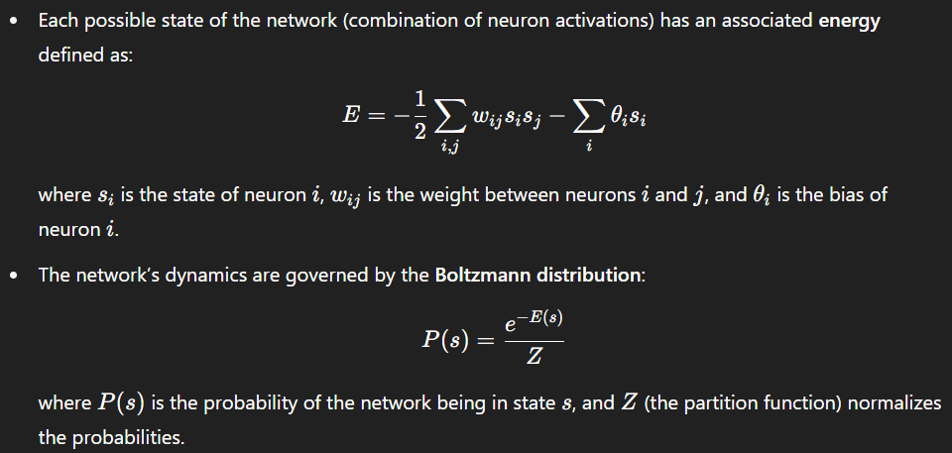

* Neurons update their states probabilistically based on their input, allowing the system to **explore the energy landscape**.
* The network tends to settle into **low-energy states**, which correspond to learned patterns or memories.

**4. Role of Temperature:**

* Inspired by physical annealing, a temperature parameter T controls the randomness in neuron activation:
  + At **high temperature**, neurons flip states more randomly, allowing exploration.
  + At **low temperature**, the network settles into stable states.
* Cooling the system slowly (simulated annealing) helps the network find **global minima** of the energy function.

**5. Applications:**

* **Associative memory:** Recall patterns from noisy or partial inputs.
* **Optimization:** Solve complex combinatorial problems by energy minimization.
* **Feature learning:** Extract hidden features from data distributions.
* **Pre-training layers** in deep learning models (e.g., using Restricted Boltzmann Machines).

**6. Limitations:**

* Training full Boltzmann Machines is **computationally expensive** due to recurrent connections and the need for extensive sampling.
* The presence of many hidden units makes exact computation of probabilities infeasible.
* Restricted Boltzmann Machines (RBMs) simplify the architecture for practical training.

**Boltzmann Learning**

**1. Introduction:**  
**Boltzmann Learning** is the unsupervised learning algorithm designed to train Boltzmann Machines by adjusting the weights to make the model distribution approximate the data distribution. It aims to increase the probability of observed data patterns while decreasing the probability of others.

**2. Learning Objective:**  
The network learns by minimizing the difference between the **expected correlations** of neurons under the training data and under the model’s own distribution.

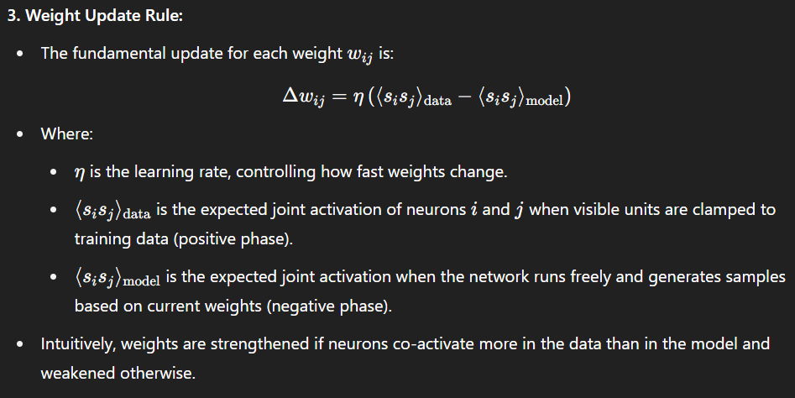

**4. Learning Process Steps:**

* **Positive phase:** Clamp visible units to data patterns, allow hidden units to update, measure correlations.
* **Negative phase:** Let the entire network run freely (no clamping), sample states, measure correlations.
* **Weight adjustment:** Use the difference in correlations to update weights.

**5. Challenges in Learning:**

* Computing the negative phase expectation is **expensive** because it requires sampling from the full joint distribution over all neurons.
* Training is slow due to the need for **many iterations** of sampling.
* To overcome this, approximate methods like **Contrastive Divergence (CD)** are used, which run the negative phase for only a few steps.

**6. Importance:**

* Boltzmann Learning allows the network to learn complex, multimodal distributions.
* It is a foundational method that inspired later developments in deep learning, including RBMs and Deep Belief Networks.

**Advantages of Boltzmann Machines**

* **Ability to Learn Complex Distributions:** BMs can model complex, multimodal probability distributions, making them powerful for unsupervised learning tasks.
* **Generative Model:** They can generate new samples similar to the training data, useful for tasks like image and speech synthesis.
* **Escape Local Minima:** Due to stochasticity and temperature-based exploration, BMs can escape local minima during training.
* **Flexibility:** Can be applied to a wide variety of problems, including optimization, classification, and feature learning.

**Limitations of Boltzmann Machines**

* **Computationally Expensive:** Training requires extensive sampling and running the network in both positive and negative phases, which is very slow for large networks.
* **Scaling Issues:** The fully connected structure leads to a large number of weights, making it impractical for large-scale problems.
* **Difficult to Train:** Weight updates rely on estimating expectations over the network’s distribution, which requires approximate methods like Gibbs sampling, making convergence slow.
* **Requires Careful Tuning:** The temperature schedule and learning rate must be carefully tuned for effective training.

**Architecture of Boltzmann Machine**

A **Boltzmann Machine (BM)** is a network of interconnected neurons arranged in a single layer or multiple layers, where every neuron is connected symmetrically to every other neuron except itself (i.e., no self-connections). The architecture can be described as follows:

1. **Units (Neurons):**
   * The network consists of binary neurons (also called units or nodes), each of which can be in one of two states: 0 or 1 (sometimes represented as -1 or +1).
   * Each neuron’s state is stochastic, meaning it is updated based on a probability that depends on the states of the neurons it connects to.
2. **Connectivity:**
   * The neurons are fully connected to each other via symmetric weights wij=wjiw_{ij} = w_{ji}wij​=wji​.
   * There are **no self-connections**, so wii=0w_{ii} = 0wii​=0 for all neurons.
   * This full connectivity means each neuron influences, and is influenced by, all others in the network.
3. **Visible and Hidden Units:**
   * In general, the neurons are divided into two sets:
     + **Visible units:** Represent observed data or inputs to the network.
     + **Hidden units:** Capture complex dependencies and features not directly observable in the data.
   * Both visible and hidden units interact through weighted connections.
4. **Symmetric Weights:**
   * The connection weights are symmetric, ensuring the network’s energy function is well-defined. This symmetry is important for the convergence properties of the network.
5. **Energy Function:**
   * The network associates an energy to every possible state configuration of the neurons:

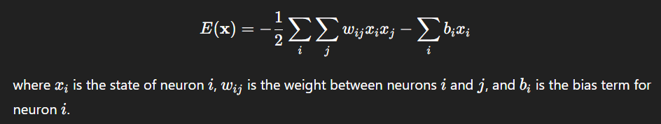

* + The network dynamics aim to reach states with minimum energy, which correspond to learned patterns.

1. **Stochastic Activation:**
   * Neurons update their states asynchronously using a probabilistic rule based on the weighted input sum and a temperature parameter.
   * This stochastic activation allows the network to explore multiple configurations, helping avoid local minima.

**State Transition Diagram**

**Definition:**  
A **State Transition Diagram** is a graphical representation of the dynamic behavior of a neural network, showing how the network moves from one state to another over time. Each **state** represents a particular pattern of activations of all neurons in the network.

**Details:**

* In networks like the **Hopfield network**, the network's state at any moment is a binary vector representing the activation (e.g., +1 or -1) of each neuron.
* The diagram consists of **nodes** and **directed edges**:
  + Each **node** corresponds to a possible network state (a specific activation pattern).
  + Each **edge** shows the transition from one state to the next after updating the neurons.
* The network starts in some initial state (often an input pattern) and updates neurons asynchronously or synchronously based on the activation rules.
* The network state changes at each step, moving through the state space along edges until it reaches a **stable state** (also called an attractor or fixed point), where no further changes occur.
* **Stable states** correspond to **memorized patterns** or stored memories.

**Importance:**

* The state transition diagram helps visualize how the network converges from any starting pattern to a stored memory.
* It shows the **energy landscape**, where transitions correspond to moves towards states with lower energy.

**False Minima Problem**

**Definition:**  
The **False Minima Problem** (also called **Spurious Minima** or **Local Minima Problem**) occurs when a neural network, such as a Hopfield network, converges to a stable state that is **not one of the desired stored patterns** but a **spurious or incorrect pattern**.

**Explanation:**

* In a Hopfield network, stored patterns correspond to **energy minima** in the energy landscape.
* However, because of the way weights are set and interactions between neurons, the network may develop **extra minima** in the energy function—these are not associated with any trained pattern.
* When the network state falls into such a false minimum, it will stay there indefinitely because it is a stable state, but it represents **incorrect or meaningless output**.

**Causes:**

* Storing too many patterns can lead to interference between them, increasing the number of false minima.
* Poorly chosen or highly correlated training patterns increase spurious states.

**Effects:**

* Degrades network performance by recalling wrong or meaningless patterns.
* Limits the capacity of the network to store patterns reliably.

**Ways to Mitigate:**

* Limit the number of stored patterns to below the network’s capacity (approximately 0.15 × number of neurons for Hopfield networks).
* Use learning rules that reduce spurious minima (e.g., pseudo-inverse method).
* Employ stochastic or probabilistic update methods (e.g., simulated annealing, Boltzmann machines) to escape local minima.

**1. Pattern Association**

**Definition:**  
Pattern association is the process by which a neural network learns to link or associate an input pattern to a corresponding output pattern. This is useful when the goal is to recall a stored pattern from a noisy or incomplete input, or when associating one pattern with a related but different output pattern.

**Basic Functional Units and Working:**

* **Input Layer:**  
  The network receives an input vector representing the input pattern. This can be a binary, bipolar, or continuous-valued vector depending on the application.
* **Memory/Storage Mechanism:**  
  This is the core of the network where the associations between input-output pairs are stored. The network learns a weight matrix that encodes these associations.
* **Hidden/Intermediate Units (optional):**  
  Some associative networks have hidden layers to improve storage capacity or generalization.
* **Output Layer:**  
  Produces the output pattern corresponding to the input. The output could be the same as the input (autoassociation) or different (heteroassociation).

**Types of Pattern Association:**

* **Autoassociative Memory:**
  + Input and output patterns are the same or very similar.
  + The network recalls complete patterns when given partial or corrupted versions.
  + Example: Hopfield Network.
* **Heteroassociative Memory:**
  + Input and output patterns are different but related.
  + The network learns to map inputs to different output patterns.
  + Example: Bidirectional Associative Memory (BAM).

**Example Network:**

* **Hopfield Network:**  
  A recurrent network that stores patterns as stable states. When given a noisy input, the network settles into the closest stored pattern.

**Applications:**

* Recall of stored memories from partial cues.
* Error correction in noisy data.
* Pattern completion in signal processing.

**2. Pattern Classification**

**Definition:**  
Pattern classification is the process of assigning an input pattern to one of several predefined categories or classes. The ANN learns decision boundaries in the input space to separate different classes.

**Basic Functional Units and Working:**

* **Input Layer:**  
  Receives the feature vector of the input pattern. Features are numerical values representing the characteristics of the pattern.
* **Hidden Layers:**  
  One or more hidden layers process the input features to extract complex features and transform the input space for better class separation. Hidden neurons use nonlinear activation functions (e.g., sigmoid, ReLU) for flexibility.
* **Output Layer:**  
  The output layer has one neuron per class. The neuron with the highest activation (or output value) indicates the predicted class of the input.
* **Decision Function:**  
  The network applies a rule to classify the input, often selecting the class corresponding to the neuron with maximum output (winner-takes-all).

**Popular Architectures:**

* **Perceptron:**  
  A simple linear classifier for linearly separable data.
* **Multilayer Perceptron (MLP):**  
  Uses backpropagation to train multiple layers, capable of learning nonlinear decision boundaries.
* **Radial Basis Function (RBF) Network:**  
  Uses radial basis neurons in hidden layers for local receptive fields, suitable for classification.

**Training:**  
Supervised learning is used, where the network is trained with labeled examples of input-output pairs. The error between predicted and actual class labels guides the weight adjustments.

**Applications:**

* Handwritten digit recognition.
* Medical diagnosis (classifying disease conditions).
* Speech recognition.
* Image classification.

**3. Pattern Mapping**

**Definition:**  
Pattern mapping is a task where an ANN learns a direct mapping or transformation from input patterns to output patterns, which may be in different domains or of different sizes. This includes regression, function approximation, and sequence mapping.

**Basic Functional Units and Working:**

* **Input Layer:**  
  Receives the input vector or sequence to be mapped.
* **Hidden Layers:**  
  Extract features and learn intermediate representations to capture the underlying mapping function. Multiple layers can capture complex nonlinear transformations.
* **Output Layer:**  
  Produces the output vector or pattern, which may be continuous-valued or discrete, depending on the task.
* **Mapping Function:**  
  The network approximates a function f:X→Yf: X \rightarrow Yf:X→Y, where XXX is the input space and YYY is the output space.

**Common Architectures:**

* **Feedforward Neural Networks:**  
  Standard multilayer networks used for regression or general mapping tasks.
* **Encoder-Decoder Networks:**  
  Used for sequence-to-sequence mapping (e.g., language translation, speech synthesis).
* **Convolutional Neural Networks (CNNs):**  
  Often used for image-to-image mapping tasks (e.g., style transfer).

**Training:**  
Supervised learning with pairs of input-output patterns. The network minimizes a loss function measuring the difference between predicted outputs and actual outputs.

**Applications:**

* Function approximation in control systems.
* Time-series prediction (e.g., stock prices).
* Image enhancement or transformation.
* Language translation or speech recognition.

**Unit – 4**

**Competitive Learning Network**

A Competitive Learning Network is a type of artificial neural network used primarily for unsupervised learning tasks such as clustering and pattern recognition. In this network, neurons in the output layer compete to become active, and only the "winning" neuron gets to learn from the input pattern.

How it works:  
When an input vector is presented to the network, each neuron in the competitive layer calculates its similarity to the input, typically by measuring the distance between the input and the neuron's weight vector. The neuron whose weight vector is closest to the input — meaning it has the highest similarity — is declared the winner. This is often called the *winner-takes-all* rule.

Once a winner neuron is selected, its weights are adjusted to move closer to the input vector, making it more likely to win for similar inputs in the future. Other neurons do not change their weights. Over time, this process causes different neurons to specialize in representing different clusters or groups in the input data.

Applications:  
Competitive learning is used in vector quantization, clustering, feature extraction, and dimensionality reduction tasks. It forms the basis of algorithms like Kohonen’s Self-Organizing Maps (SOM).

Summary:  
Competitive Learning Networks help organize data by allowing neurons to compete for representation, learning prototypes that summarize groups of similar inputs without needing labeled **training data.**

**Components of a Competitive Learning Neural Network and Their Contributions**

1. **Input Layer:**
   * **Description:** Consists of neurons that receive the input data vector. Each neuron corresponds to one feature or dimension of the input.
   * **Contribution:** Serves as the entry point for data into the network, presenting the raw input patterns for processing.
2. **Competitive (Output) Layer:**
   * **Description:** Contains neurons that compete to respond to the input pattern. Usually, only one neuron (or a small group) wins this competition and becomes active.
   * **Contribution:** Performs the selection of the neuron whose weight vector best matches the input, enabling the network to assign the input to a specific cluster or category.
3. **Weight Vectors (Synaptic Weights):**
   * **Description:** Each neuron in the competitive layer has an associated weight vector, representing a prototype or centroid in the input space.
   * **Contribution:** Encodes the learned representation of a cluster or feature pattern. During training, these weights are updated to better represent the input data assigned to that neuron.
4. **Competition Mechanism (Winner-Takes-All):**
   * **Description:** A process or rule where neurons compete, and only the neuron with the highest activation (closest match) wins.
   * **Contribution:** Ensures that only one neuron updates its weights per input, allowing specialization and avoiding interference among neurons.
5. **Learning Rule:**
   * **Description:** The algorithm that updates the winning neuron’s weights by moving them closer to the input vector, typically using a small learning rate.
   * **Contribution:** Enables adaptation and learning by refining neuron prototypes to better represent the input clusters over time.
6. **Normalization Unit (Optional):**
   * **Description:** A component that keeps the weight vectors normalized (e.g., unit length) for consistent distance or similarity measurement.
   * **Contribution:** Helps maintain stability and comparability of weights, improving the accuracy of competition and convergence.

**Example and Learning Algorithm of Competitive Learning Network**

**Example:**  
Imagine you have a dataset of different colors, and you want the network to group similar colors together without knowing their names beforehand. Each input to the network is a color represented by its RGB values (e.g., [255, 0, 0] for red). The network’s neurons will compete to represent groups of similar colors — one neuron might learn to represent shades of red, another blue, and so on.

**Learning Algorithm (Step-by-Step):**

1. **Initialize weights:**  
   Assign random weight vectors to each neuron in the competitive layer.
2. **Present input:**  
   Input a pattern (e.g., a color vector) to the network.
3. **Calculate similarity:**  
   Each neuron computes the distance (often Euclidean) between its weight vector and the input vector.
4. **Select winner:**  
   The neuron with the smallest distance (closest match) is the winner.
5. **Update weights:**  
   Adjust the winner’s weights to move closer to the input using:
6. 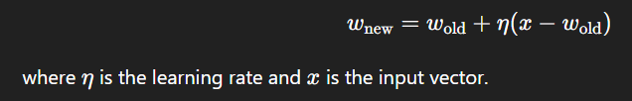**Repeat:**  
   Repeat the process for many input patterns until weights stabilize.

**Result:**  
After training, each neuron’s weight vector represents a cluster center in the input space, allowing the network to classify or group new inputs by assigning them to the neuron with the closest weight.

**Pattern Clustering**

**Definition:**  
Pattern clustering is the process by which similar input patterns are grouped together based on their features or characteristics, without any prior knowledge of class labels. In neural networks, this is typically done through unsupervised learning, where the network identifies natural groupings or clusters in the input data.

**How it works:**

* The network receives input patterns and compares them to learned prototypes or cluster centers (weight vectors).
* Through competition among neurons (as in competitive learning), the network assigns each input to the cluster represented by the closest neuron.
* Over time, neurons adjust their weights to better represent their assigned cluster, improving the grouping of similar patterns.

**Applications:**

* Data compression and vector quantization.
* Market segmentation.
* Image segmentation and grouping.

**Feature Mapping Network**

**Definition:**  
A feature mapping network is a type of neural network that transforms high-dimensional input data into a lower-dimensional representation, preserving the topological and neighborhood relationships of the input patterns. This process helps in visualizing, organizing, and understanding complex data structures.

**How it works:**

* Networks like the **Self-Organizing Map (SOM)** learn to map similar input patterns to nearby neurons on a 2D grid.
* During training, neurons adjust their weights not only individually but also influence their neighbors, preserving the spatial relationships of input features.
* This creates a meaningful low-dimensional map that reflects the input space structure.

**Applications:**

* Data visualization and dimensionality reduction.
* Pattern recognition.
* Exploratory data analysis.

**Definition of ART Network**

Adaptive Resonance Theory (ART) is a neural network model designed for unsupervised learning that solves the stability-plasticity dilemma — enabling the network to learn new information without forgetting previously learned patterns. It clusters input patterns by dynamically creating or updating categories based on similarity and a vigilance parameter.

**Architecture of ART Network**

ART networks mainly consist of two layers:

* **F1 Layer (Input Layer):**  
  Processes and holds the input pattern. It acts as a comparison field for matching the input with learned categories.
* **F2 Layer (Category Layer):**  
  Contains neurons representing learned categories or clusters. Each neuron corresponds to a specific prototype pattern.
* **Gain Control and Reset Mechanisms:**  
  These regulate competition and help reset the search when no suitable category is found.
* **Vigilance Parameter:**  
  A threshold that controls how closely an input pattern must match a stored category for assignment.

**Working of ART Network**

1. **Input Presentation:**  
   An input pattern is presented to the F1 layer.
2. **Category Matching:**  
   The F2 layer neurons compete to find the best matching category based on similarity with the input.
3. **Vigilance Test:**  
   The winning neuron’s match is tested against the vigilance parameter.
   * If the match meets or exceeds the vigilance threshold, resonance occurs.
   * If the match is below the threshold, the winning neuron is inhibited, and the next best match is tested.
4. **Learning:**  
   When resonance occurs, weights are updated to reinforce the category, adapting it to better represent the input pattern.
5. **Category Creation:**  
   If no existing category passes the vigilance test, a new category neuron is recruited for the input pattern.

**Types of ART Networks**

* **ART1:**  
  Designed for binary input patterns (0s and 1s). It uses simple matching and learning rules suitable for discrete data.
* **ART2:**  
  Extends ART1 to handle continuous-valued input patterns, allowing for real-world analog data processing.
* **ART3:**  
  Incorporates more biologically inspired mechanisms such as neurotransmitter effects, adding complexity and biological realism.

**Features of ART Network**

1. **Stability-Plasticity Balance:**  
   The ART network can learn new patterns (plasticity) while preserving previously learned categories (stability), avoiding catastrophic forgetting.
2. **Vigilance Parameter:**  
   Controls the degree of similarity required to classify an input into an existing category, balancing generalization and specificity.
3. **Fast and Stable Learning:**  
   Learning occurs quickly through weight updates when resonance is achieved, and the network remains stable without constant retraining.
4. **Incremental Learning:**  
   Can continuously learn from new data without the need to retrain from scratch.
5. **Noise Tolerance:**  
   Robust to noisy or incomplete input patterns, as it can still correctly classify or create new categories.
6. **Unsupervised Learning:**  
   Does not require labeled data; it automatically clusters input patterns based on similarity.
7. **Dynamic Category Creation:**  
   Creates new categories as needed, allowing the network to adapt to novel inputs flexibly.

**Using ART for Character Recognition**

ART networks are well-suited for character recognition because they can learn to classify patterns (characters) without forgetting previously learned ones, even as new characters or variations are introduced.

**Step-by-step process:**

1. **Input Representation:**  
   Each character (such as a handwritten letter or digit) is converted into a suitable input format, often a binary or grayscale pixel matrix flattened into a vector. For example, a 28x28 pixel image becomes a 784-element input vector.
2. **Input to ART Network:**  
   The input vector is fed into the ART network’s input layer (F1).
3. **Category Matching:**  
   The ART network compares the input character vector to existing category prototypes stored in the recognition layer (F2). It measures similarity between the input and each learned pattern.
4. **Vigilance Test:**  
   The network checks if the best-matching category is similar enough based on the vigilance parameter. This controls whether the network recognizes the input as belonging to a known character or treats it as a new character.
5. **Learning and Classification:**
   * If a match passes the vigilance test, the network assigns the input to that character’s category and updates the prototype to better represent variations in handwriting or style.
   * If no match passes, the network creates a new category neuron to represent this novel character or style.
6. **Recognition Result:**  
   After training, when a new character is presented, the ART network quickly classifies it by matching it to the most similar stored category.

**Advantages of Using ART for Character Recognition**

* **Stable learning:** Learns new characters or styles without forgetting old ones.
* **Handles noisy inputs:** Can recognize characters even if the input is partially distorted or incomplete.
* **Unsupervised learning:** Does not require labeled data, useful for unsupervised clustering of character styles.
* **Adaptive:** Continuously adapts to new handwriting styles or fonts.

**Self-Organizing Maps (SOM)**

**1. Introduction**

* Self-Organizing Map (SOM), also known as Kohonen Map, is a type of **unsupervised artificial neural network**.
* It is used to **map high-dimensional data** into a **low-dimensional (usually 2D)** grid while **preserving the topological structure** of the data.
* Developed by **Teuvo Kohonen**, SOM is mainly used for **clustering**, **visualization**, and **dimensionality reduction**.

**2. Key Characteristics**

* **Unsupervised Learning:** No labels are required for training.
* **Topology Preservation:** Similar data points are mapped close together on the 2D grid.
* **Dimensionality Reduction:** Converts multi-dimensional data into a 2D representation.

**3. SOM Architecture**

* **Input Layer:** Each input vector has n features (dimensions).
* **Output Layer (Map):** A 2D grid of neurons, where each neuron has a weight vector of dimension n.

Example:  
If input has 4 features, each neuron has a 4D weight vector.

**4. SOM Algorithm (Working Steps)**

**Step 1: Initialize Weights**

* Initialize the weight vectors of all neurons randomly or using PCA.

**Step 2: Select an Input Vector**

* Randomly choose an input vector from the dataset.

**Step 3: Find Best Matching Unit (BMU)**

* Calculate the **Euclidean distance** between the input vector and all neurons.
* The neuron with the smallest distance is the **BMU**.

**Step 4: Update Weights**

* Update the weights of the **BMU** and its neighboring neurons:

W(t+1)=W(t)+α(t)⋅h(t)⋅(X−W(t))W(t+1) = W(t) + \alpha(t) \cdot h(t) \cdot (X - W(t))W(t+1)=W(t)+α(t)⋅h(t)⋅(X−W(t))

Where:

* W(t)W(t)W(t): weight vector
* α(t)\alpha(t)α(t): learning rate
* h(t)h(t)h(t): neighborhood function
* XXX: input vector

**Step 5: Decrease Parameters**

* Gradually reduce the **learning rate** and **neighborhood radius** over time.

**Step 6: Repeat**

* Repeat steps 2 to 5 for a number of epochs until the map stabilizes.

**5. Neighborhood Function**

* Determines how much neighboring neurons are updated.
* Often modeled using a **Gaussian function** centered at the BMU.
* Ensures smooth and topological updates across the map.

**6. Features of SOM**

* **Visual Clustering:** Groups similar data into clusters on the map.
* **Topological Mapping:** Maintains spatial relationships in data.
* **Dimensionality Reduction:** Useful for visualizing complex data.

**7. Applications**

* **Data Visualization** (e.g., customer data, market segmentation)
* **Medical Diagnosis** (grouping symptoms or patients)
* **Image and Speech Recognition**
* **Anomaly Detection**
* **Document or Text Clustering**

**8. Advantages**

* Intuitive and interpretable 2D representation of high-dimensional data.
* Simultaneously performs **clustering** and **dimensionality reduction**.
* Preserves **data relationships** in the mapped grid.

**9. Limitations**

* Requires careful **parameter tuning** (learning rate, map size, etc.).
* **Computationally expensive** for large datasets.
* Sensitive to **initialization** and may get stuck in local minima.

**10. Example**

Imagine analyzing customer behavior using 4 attributes: age, income, spending score, and savings. SOM can project these into a 2D map where each neuron represents a customer segment. Nearby neurons represent similar customers, aiding in **targeted marketing**.

**Two Basic Feature Mapping Models**

Feature mapping models are used in machine learning and neural networks to transform input data into a space where patterns or classifications are easier to identify. The two basic feature mapping models are:

**1. Competitive Learning Model (Winner-Takes-All)**

**Definition:**

* In this model, multiple neurons compete to respond to a given input.
* Only **one neuron**, the **Best Matching Unit (BMU)**, is declared the **winner** and gets updated.

**Working:**

* The neuron with the **weight vector closest** to the input vector is selected as the winner.
* Only the winner’s weights are adjusted to become more like the input vector.
* This leads to **specialization** of neurons, where each learns to respond to different input patterns.

**Example:**

* Used in **Self-Organizing Maps (SOM)** and **Kohonen Networks**.

**Advantages:**

* Simple and fast.
* Useful for **clustering** and **pattern recognition**.

**2. Cooperative Learning Model**

**Definition:**

* In this model, **multiple neurons** (not just the winner) cooperate to learn from the input.
* The **winner** and its **neighboring neurons** are updated, typically based on a **neighborhood function**.

**Working:**

* The strength of weight update decreases with distance from the winner in the grid.
* This promotes **topological ordering**, preserving the structure of input data.

**Example:**

* Core concept in **Self-Organizing Maps (SOM)**, where both the BMU and its neighbors are updated.

**Advantages:**

* Helps in maintaining **smooth mapping** and **continuity** in the feature space.
* Produces more **organized and structured maps**.